REPORT HW3
Odd Jørgen Rye Salvesen, Reidar Sivert Greve, Endre Hammerlund Fangel

Task 5.4
We first loaded the provided trajectories generated under SpaceY’s policy, and plotted the state-value function.
Yes, MC improvement can be performed because we estimated $Q_{π}\left(a,s\right)$ from the given trajectories. A greedy policy$π^{´}(s) = argmax_a$ $Q_{π}\left(a,s\right)$ was derived.
However, the improved policy is not guaranteed to be optimal. The dataset is fixed and generated under π, meaning several state–action pairs are poorly explored or unseen. Limited coverage leads to unreliable estimates and prevents full convergence to the optimal policy.
Task 5.5
We discussed that all trajectories are not equally useful.
First of all because of For Monte Carlo evaluation, the usefulness of a trajectory depends on how many informative visits it provides to each state or state–action pair. States that are frequently visited obtain low-variance estimates, while rarely visited states suffer from high variance. Therefore, coverage of the state space is more important than the sheer number of trajectories.
For Monte Carlo improvement, trajectories are particularly useful when they provide informative comparisons between different actions in the same state. A trajectory with high total reward is not necessarily more valuable unless it improves the estimation of specific action-values. Longer trajectories that visit many distinct state–action pairs generally contribute more information than short, repetitive ones.
Task 5.6
Full MC control cannot be performed using only the provided trajectories. MC control requires iterative policy improvement followed by new data collection under the updated policy. Since the dataset is fixed, we can only perform a single greedy improvement step, not full control.
Task 5.7
Task 5.9
Task 5.12
Task 5.14
We looked at average return/episode, and got the following plot:
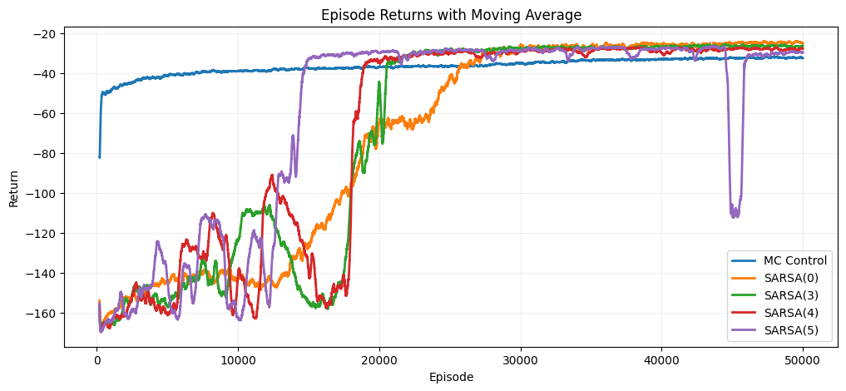
We noticed that mc converges much faster but sarsa achives better returns/episode. We also noticed that Sarsa seems to be unstable for larger n? ex fluctuation for sarsa(5)
Task 5.16
Q-learning

